**PRACTICAL NO.8**

**8.Write a program to control pi camera using Raspberry pi over internet.**

In this practical, we are going to do the practical of how can we use Raspberry pi camera module to capture picture over internet.

**Requirements:-**

Raspberry Pi computer with a Camera Module port

All current models of Raspberry Pi have a port for connecting the Camera Module.

**Raspberry Pi Camera Module**

**In market the two types of camera modules are available, they are:-**

1. Standard version:- These type of camera can take pictures in normal light.
2. The NoIR version:- These type of camera contains infrared lights, so, that these cameras allows us to take pictures in dark

**Circuit Diagram:-**

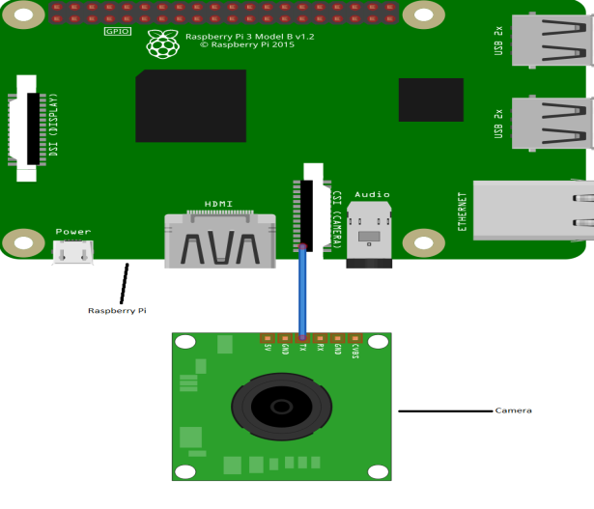

**Steps to setup camera module in Raspberry Pi:-**

1. Open and install your camera module by inserting the cable in your camera slot of the raspberry pi.

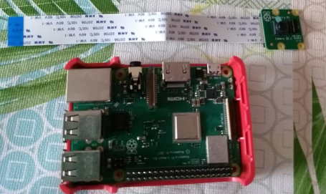

1. Boot up your raspberry pi and enable the camera. For enabling the camera in raspberry pi click on raspberry pi icon then right click on Prefrences => Raspberry Pi Configuration. A dialog box will appear in front of us, then go to interfaces => camera and select enabled and click on ok.

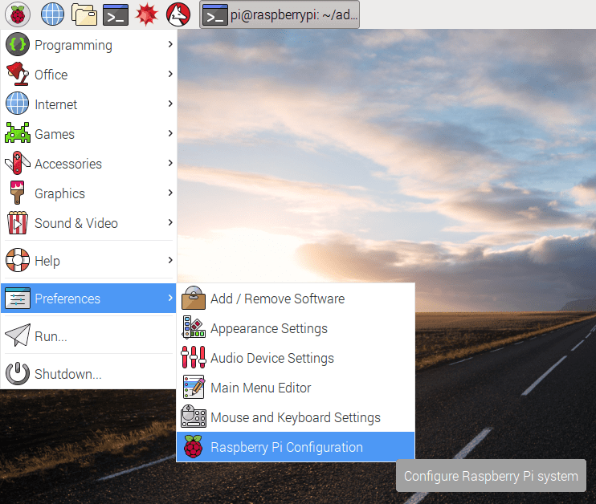

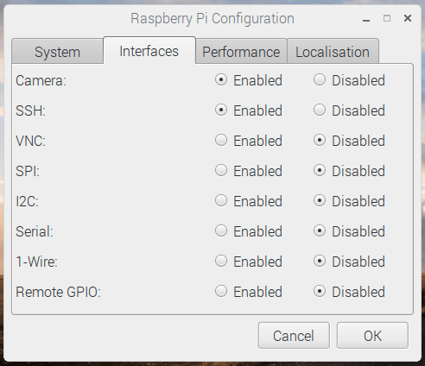

1. Open terminal of the raspberry pi and type “*sudo apt-get update”* command and after that type "*sudo apt-get upgrade*".
2. Then after write "*sudo raspi-config*" and run this command and then setting menu will open and then navigate to the camera option and enable it. Then select “Finish” and reboot your Raspberry Pi.

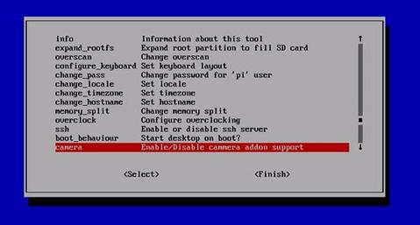

Now, open Thonny Python and write the following code and save the file by giving it .py extension.

import urllib

import cv2,time

import numpy as np

first_frame = None

url= 'http://192.168.2.52:8080/shot.jpg’

imgResp = urllib.urlopen(url)

imgNp = np.array(bytearray(imgResp.read()),dtype=np.uint8)

img = cv2.imdecode(imgNp,-1)

cv2.namedWindow(‘image’,cv2.WINDOW_NORMAL)

cv2.resizeWindow(‘image’,600,600)

i=0

while True:

imgResp=urllib.urlopen(url)

imgNp=np.array(bytearray(imgResp.read()),dtype=n.uint8)

img=cv2.imdecode(imgNp,-1)

cv2.imshow(‘image’,img)

cv2.imwrite(‘test.jpg’’,img)

key=cv2.waitKey(1)

if key==ord(‘q’):

break

cv2.destroyAllWindows

After executing this code our camera module will get enabled and capture the image and upload it on the local server. To access the image we need to open the browser and enter the <http://192.168.2.52:8080> into the address bar and hit enter. After this it opens a web page where we will get our captured images available on the server. Click ont the image and now we can view our captured images.